Revision 1 QUESTIONS

Topic 1: Linear Motion and Forces
- State Newton’s First Law.
- Explain the concept of Inertia.
- Explain the difference between mass and weight.
- Explain the motion of a skydiver jumping from an aircraft, describing the forces acting upon him and his rate of descent.
- Calculate the force acting upon a 80kg skydiver at the start of his fall.
- Determine the force acting at terminal velocity.
- Calculate the acceleration of a 924kg car with 522N acting upon it.
- Calculate the mass of a crash test dummy accelerating at 3.2m/s/s with 150N acting upon it.

Topic 2: Electric Circuits
- State what is meant by “electron current” and ”conventional current”.
- A radio draws a current of 0.65 A.
Calculate the charge that flows in 7 minutes of operation.
- Consider 1050 C of charge flows through a lamp in 7 minutes.
  - Calculate the magnitude of electric current flowing through the lamp.
  - Determine the number of electrons (q = 1.6x10⁻¹⁹ C) that flow through the lamp if it is left on for 6 hours. Assume the magnitude of current is constant during this time.
- State the types of forces (e.g. repel, attract) between particles of both like and opposite charges.
- Describe how fuses and circuit breakers work, and explain how safety is increased by using them.
- State what happens to the voltage and current when measured on a parallel circuit?
- State what happens to the voltage and current when measured on a series circuit?
- Explain three factors that can change the resistance of a conductor?
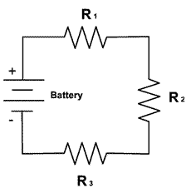
- Calculate the total resistance across the circuit below?
V₁ =3V
2A
V₃ =3V
V₂ =3V

- Calculate the total resistance of the circuit below?
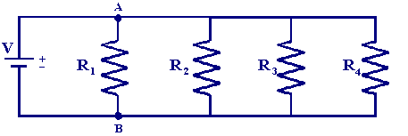
I₁ 0.2mA
I₂ 0.2mA
I₃ 0.2mA
I₄ 0.2mA
12 V

Topic 3: Heat

- State the difference between heat and temperature.
- Describe thermal equilibrium.
- Define thermal energy.
- State the three most common units of measurement for temperature.
- For the three objects below, thermal equilibrium is achieved with object A and B, and thermal equilibrium is achieved with object B and C. Describe the connection between object A, and object C.
A
B
C

- Define absolute zero.
- What is the link between temperature, vibrating particles, and thermal energy?
- Draw a diagram of a convection current coming from a heater.
- Define the term conduction and give an example of conduction in everyday life.
- Describe how thermal radiation occurs from the sun to the Earth.
- What causes thermal expansion?
- Give three examples of thermal expansion.
- Would power lines sag on a hot or cold day? Explain.
- Why is there white paint on the side of expansion joints of train lines? What would happen if black paint was used?
- Draw a diagram that has all three types of heat transfer on it.
- Explain what happens to the particles in a material when it is heated.
- What will expand more, a liquid or a solid? Why?
- Define the term ‘specific heat capacity’.
- 150mL of 23⁰C water is placed in a kettle and boiled.
If the boiling point of water is 100⁰C and 48279 J was used in the boiling process, calculate the specific heat capacity of water.
- A certain object requires 12kJ of heat to increase its temperature by 72ºC
Calculate the mass of the object if it has a specific heat capacity of 326 J.Kg⁻¹.ºC⁻¹
- Aluminium has a specific heat capacity of 904 J.Kg⁻¹.ºC⁻¹
Calculate the quantity of heat transferred in order to raise 15g of aluminium to melting point (660.3ºC) from room temperature (23⁰C)
- Explain the different effect a high specific heat capacity will have in comparison to a low specific heat capacity

