Revision 2 QUESTIONS

# Topic 1: Linear Motion and Forces

1. What is the difference between distance and displacement?
2. Calculate the average speed of a sprinter who runs a distance of 100m in 10.49 seconds
3. How far can a car travel in 4.20 seconds if it moves with an average speed of 65 m.s-1?
4. What is the difference between instantaneous speed and average speed?
5. A car decelerates from an original speed of 30m.s-1 to rest, over a period of 5.5 seconds. Calculate the average deceleration.
6. Why is slowing down an example of acceleration?
7. A horse accelerates at a constant rate of 1.5m.s-2 from an initial speed of 12m.s-1

Calculate the final speed of the horse after 5.0 seconds

1. State Newton’s Third Law.

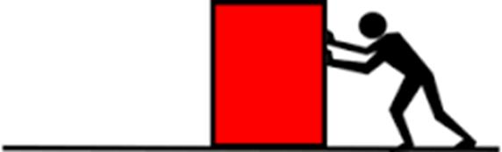

Friction: 125N ---------->

Calculate the magnitude and state the direction of the net force when a horizontal pushing force of 166.8N to the left of the page. Calculate the magnitude and state the direction of the acceleration of the box.

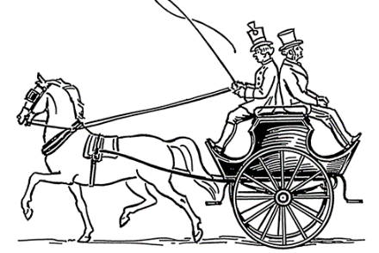

An 730kg horse pulls a cart and two riders horizontally along a flat surface with an average acceleration of 0.16m/s/s to the left.  
Calculate the magnitude of the net force acting upon the horse, and the direction.

1. $a)$ A car is driving at a constant speed of 50km/h (13.9m/s) when a child runs onto the road in the path of the driver

*The driver places his foot on the brake and the car comes to rest in 3.17 seconds*

*What is the average deceleration of the car over this time?*

$b)$ The child is 21 metres from the driver when the driver first applies the brakes

*State whether the car will stop before contacting the child.*

1. Traffic police use the length of skid marks to approximate the initial velocity of a car involved in a road safety violation

The length of the skid marks left by a car on the main road in Adelaide were 46 m long.

Other tests made by Traffic police approximate the deceleration of the car to be 5.6 m. s

*Show a calculation and determine whether the driver was exceeding the limit of 16 m. s-1*

1. A seagull flies 23 metres above the water surface.

The seagull spots a fish in the water and falls vertically down in the direction of the fish.

*Ignore air resistance.*

$a)$ Calculate the time taken for the seagull to contact the water surface.

$b)$ calculate the velocity of the seagull as it enters the water

$c)$ explain why the seagull is no longer in freefall when it enters the water.

.

# Topic 2: Electric Circuits

1. If 2 particles have the same electrical charge do they repel or attract?
2. If 2 particles have opposite electrical charges do they repel or attract?
3. What is the electrical charge of a proton?
4. What is the electrical charge of an electron?
5. What is the charge of a neutron?
6. What are electrical phenomena events?
7. What is the difference between charging by conduction and charging by induction?
8. What are two examples of an electrical phenomena?
9. A current of 12A flows through a kettle which is operating at a voltage of 240V. Determine the electrical power consumed by the kettle in Watts (W)
10. How much energy is transformed by a 70W light bulb that is operating for 60 minutes?
11. A lamp has an efficiency rating of 9%. Calculate the useful output energy when 5000J of electrical energy is supplied.
12. A circuit is operated at 240V and the electrical power consumed is 4000W. determine the current flowing through the circuit.
13. A globe is supplied with 1600J of electrical energy. It transforms 80J of this into light. Calculate the efficiency of the light globe.

# Topic 3: Heat

1. Define ‘latent heat’
2. Explain two differences between evaporation and boiling (can use a diagram)
3. a) The melting point of copper is 1,085 °C  
   Calculate the quantity of heat required to melt 2.25kg of copper at 1,085 °C  
   The latent heat of fusion of copper is 205 000 J.kg-1

b) The boiling point of bromine is 58.8ᵒC  
Calculate the quantity of heat required to vaporise 20g of bromine at 58.8ᵒC  
The latent heat of vaporisation of bromine is 193 000 J.kg-1

1. a) At temperatures below 0ᵒC, water vapour transitions directly into ice. State the term used to describe this transition.

b) Why does this occur?

1. Label the arrows on this diagram.

