Revision 1 ANSWERS

Topic 1: Linear Motion and Forces
- An object will remain at rest, or continue in its motion, unless acted upon by an unbalanced force.
- Inertia is the resistance of an object to any change of motion, for example, if a car is travelling at high speed, and stops suddenly, people sitting inside the car will still move forwards, until their seatbelts apply enough force in the opposite direction to stop them from moving.
- Mass is how much material is contained within a body, whereas weight is the force exerted by gravity on that object. While mass is the same everywhere, weight changes depending on gravity.
- When a skydiver jumps from an aircraft, the drag of his (or her) body is much less than his weight, so the resultant force is down. This means his acceleration increases, and he falls downwards. The drag increases, until he has reached terminal velocity, and the forces are equal. He now stops accelerating, and instead falls downwards at a fixed speed.
- $F=ma$
$80×9.8=$784N (2 s.f.)
- 0 N
- $F=ma$
$∴a=\frac{F}{m}=\frac{522}{924}=$0.565 m/s/s
- $F=ma$
$∴m=\frac{F}{a}=\frac{150}{3.2}=$47 kg.

Topic 2: Electric Circuits
- Both are the movement of charged particles (electrons) through a circuit. Electron current flows from negative to positive, and conventional current from positive to negative.
- $I=\frac{q}{Δt}$ $∴q=Δt I=\left(7×60\right)×0.65=273$ C (2 s.f.)

  - $I=\frac{q}{Δt}$ $∴I=\frac{1050}{7×60}=2.5 A$
  - $N=\frac{q}{q_{e}}$ and $q=IΔt$ $∴N=\frac{2.5×(60×60×6)}{1.6×{10}^{-19}}=3.4×{10}^{23}$
- Like charges repel (+ and +) or (– and –).
Unlike charges attract (+ and –).
- Fuses are small tubes with a wire that are attached to circuits. When the wire gets too hot, it melts and breaks the circuit. Likewise, circuit breakers contain bimetallic strips which connect the circuit, but when heated the bimetallic strip bends and breaks the circuit. Safety is increased by doing this because it ensures that the circuit doesn’t get too hot and cause fires, and cuts off power to short circuits or electrocution hazards.
- In a parallel circuit the voltage across components stays the same and in a parallel circuit the current through components adds together. I_{T} = I₁+I₂+I₃+I₄
- In a series circuit the voltage across components adds together V_{T} = V₁+V₂+V₃ ,and in a series circuit the current through components stays the same
- The resistance of a conductor depends on the length, area of a cross section, temperature, and the type of material or resistivity.
VOLTAGE=9V
CURRENT=2A
use the formula R=^{V}/_{I}
RESISTANCE=4.5 $Ω$

VOLTAGE=12V
CURRENT=0.8mA
use the formula R=^{V}/_{I}
RESISTANCE=15 $Ω$

Topic 3: Heat
- Temperature is a measure of the average kinetic energy of particles in a material
Heat is the flow of energy from hot to cooler objects
- Thermal equilibrium is where two objects are brought into contact with each other. The heat flows between the two objects until there is no temperature difference, at this point they are in thermal equilibrium.
- The sum of the potential (stored in bonding) and kinetic (movement) energies of a particle is referred to as thermal energy.
- Celsius, Fahrenheit, Kelvin
- Object A and object C are in thermal equilibrium even though they aren’t touching. Object A is the same temperature as object B, which is the same temperature of object C, therefore objects A and C are in thermal equilibrium.
- Absolute zero is the lowest temperature which is possible. Absolute zero is where the motion of particles stop.
- Temperature, thermal energy and the vibrating of particles are almost the same thing. Temperature is related to average kinetic energy (vibration) of particles; thermal energy is the scientific word for the total energy in the vibrating particles.

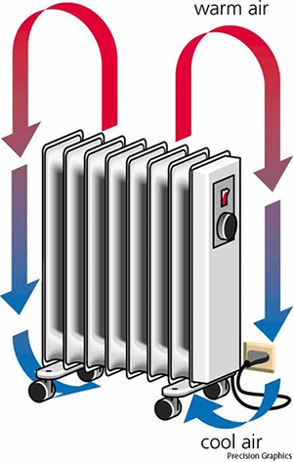

- Conduction is the process of heat transfer between two objects that are in direct contact. An example of conduction is; a frypan on a stove top, cheese melting in a burger or spoon in coffee getting hotter at the end.
- Electromagnetic radiation (such as infra-red, visible light and ultra-violet) are emitted from the sun towards the Earth. This radiation is then absorbed by atoms and molecules in the surface of the Earth. The radiation is absorbed by molecules called greenhouse gases.
- Thermal expansion is caused by a change in temperature.
- Expansion joints on train lines, expansion of oceans, bimetallic strip, cart wheel ‘tyres’, and ice water.
- Power lines sag on hot days as the lines expand due to a rise in temperature, causing it to sag slightly.
- The white paint is used to help reflect the heat off the tracks so they do not expand further then the expansion joint allows. If black paint was used, then the tracks would absorb the heat meaning that it would expand quicker than if white paint was used.
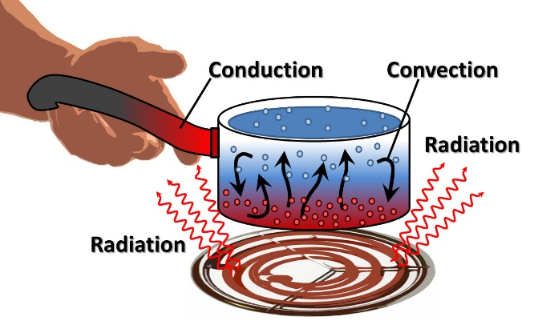

- When heated, the particles vibrate more rapidly. This is increases the separation between particles and it weakens the force of attraction between particles. Due to the particles getting further apart, the material expands. (Special case: water, gets bigger when freezes)
- Liquids expand more than solids as the electrical forces of attraction are weaker in the liquid.
- Specific heat capacity is the measure of the quantity of heat required to change the temperature of a one-kilogram mass of material by 1ºC
- $c=\frac{Q}{m∆T}$
$c=\frac{48279}{0.150 ×\left(100-23\right)}$
$c=$ 4180 J.Kg⁻¹.ºC⁻¹
- $c=\frac{Q}{m∆T}$
$$∴$$
$$m=\frac{Q}{c∆T}$$
$$m=\frac{12000}{326×72}$$
$m=$0.51Kg
- $c=\frac{Q}{m∆T}$
$$∴$$
$$Q=mc∆T$$
$$Q=0.015×904×\left(660.3-23\right)$$
$Q=9.0×10$³J
- An object with a high specific heat capacity will require a high amount of heat in order to raise the temperature whereas an object with a low specific heat capacity will only require a small amount of heat to raise the temperature.

