DO WE NEED BIG SCIENCE?
Stage 2 Physics – Assessment Type 1: Investigations Folio
Science as a Human Endeavour Task

Some of the tools needed to investigate cutting edge physics are large projects that require large teams of scientists and millions (or billions) of dollars - this is often termed “Big Science”.

Your task is to explain the physics behind your chosen topic related to the stage 2 Physics course and focus on an aspect (or several aspects) of Science as a Human Endeavour in the development, influences, collaboration/communication or application of the project.

This table contains some examples of “Big Science”, however there are many more examples and please feel free to find a project that interests you that is not in the list:

The Square Kilometre Array | Australian Synchrotron
OPAL (Open-Pool Australian Lightwater reactor) | Bragg Institute
The Relativistic Heavy Ion Collider | Large Hadron Collider
Laser Interferometer Gravitational-Wave Observatory | Hubble Telescope
National Ignition Facility (High powered LASER) | Juno (Jupiter Orbiter)
ITER (International Thermonuclear Experimental Reactor) | Advanced Light Source
Super-Kamiokande Neutrino Detector | The Earthscope

It is important that you consider the physics of the project as well as the interplay between physics and society - how society shapes physics and how physics in turn shapes society. Please read the subject outline but this graphic gives you an overview of the main aspects of Science as a Human Endeavour.

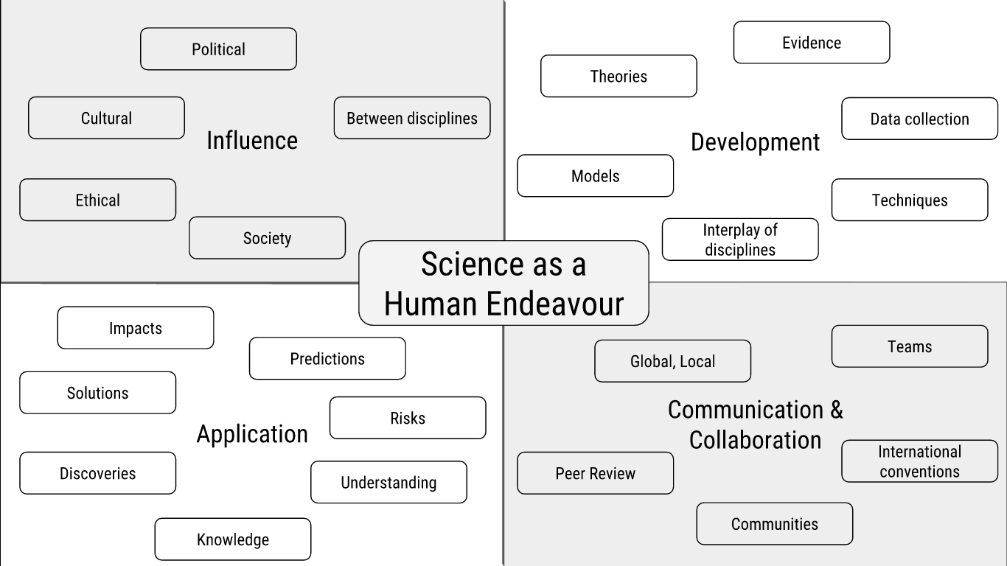

Based on your investigation, you will prepare a scientific report, which must include the use of scientific terminology and:
- an introduction to identify the focus of the investigation and the key concept(s) of science as a human endeavour that it links to
- relevant physics concepts or background
- an explanation of how the focus of the investigation illustrates the interaction between science and society
- a discussion of the potential impact or application of the focus of the investigation, e.g. further development, effect on quality of life, environmental implications, economic impact, intrinsic interest
- a conclusion summarising the connection between the big science project and your selected SHE concepts
- citations and reference list or bibliography.
The scientific report should be a maximum of 1500 words* if written, or a maximum of 10 minutes for an oral presentation, or the equivalent in multimodal form.

*The word-count includes headings, direct quotations, and footnotes that are used as explanatory notes. The word-count does not include the title/question page or the reference list or bibliography (including footnotes or in-text references that are used to list author, date, and page numbers).

